July 1, 2022
Dear People of God,
This past week’s rulings by the Supreme Court, especially Dobbs v. Jackson, have been deeply painful and have resulted in many of us feeling significant anxiety and emotional distress. Gun violence, women’s access to healthcare, and the degradation of God’s creation are emotional, complex, and for many, deeply personal realities. This is a time for compassion, understanding, mutual support and respect. “For God hath not given us the spirit of fear; but of power, and of love, and of a sound mind.” (2 Timothy 1:7)
Who we are as the people of the Episcopal Diocese of Central New York is unchanged. We are resolute in our commitment to the Gospel of Jesus Christ, fulfilling our baptismal vows:
- growing in our faith;
- seeking and serving Christ in all persons ;
- striving for justice and peace;
- respecting each person’s dignity.
No one stands alone.
The Rev. Dr. Martin Luther King, Jr. said, “Injustice anywhere is a threat to justice everywhere. We are caught in an inescapable network of mutuality, tied in a single garment of destiny. Whatever affects one directly, affects all indirectly.” I encourage you to actively support and encourage one another, and to prayerfully consider ways of supporting the well-being of people in your wider community.
Today, in keeping with our diocesan Rule of Life, I invite you to learn and to pray. On the diocesan website, you will find a copy of this letter along with links to resources on the Episcopal Church’s moral positions on gun violence, women’s healthcare, and creation care.
This weekend, as we celebrate the birth of our nation, praying as always for our leaders, I invite your prayers for the Supreme Court Justices, including newly sworn-in Justice Ketanji Brown-Jackson. Let us also pray for one another and all who are feeling vulnerable, that we may offer hope and reconciliation in our hurting world.
I want to close with a blessing from St. Francis:
May God bless you with discomfort,
at easy answers, half-truths,
and superficial relationships
so that you may live
deep within your heart.
May God bless you with anger
at injustice, oppression,
and exploitation of people,
so that you may work for
justice, freedom and peace.
May God bless you with tears,
to shed for those who suffer pain,
rejection, hunger, and war,
so that you may reach out your hand
to comfort them and
to turn their pain to joy.
And may God bless you
with enough foolishness
to believe that you can
make a difference in the world,
so that you can do
what others claim cannot be done,
to bring justice and kindness
to all our children and the poor.
Amen.
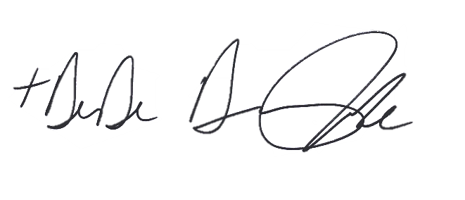
May our world be healed by love,

The Rt. Rev. Dr. DeDe Duncan-Probe
Bishop of Central New York

